**II - METHODOLOGY**

This section discusses the set of methods and procedures, software development methodology, data gathering techniques, and the sources of data used to design and develop the SOLREI: The Universe and the Solar System, a Virtual E-Learning Mobile Application for the grade - 6 students of Panpacific University North Philippines Tayug Campus.

**Research Design**

The proponents used applied research in this study. Applied research is a type of research design that provides innovative solutions to issues affecting an individual, group or society [8]. Since it involves feasible implementation of scientific methods to deal with everyday problems, it is then referred to as inquiry or contractual research. This method is used in this study to identify the problems encountered and the current procedures in teaching the topic the universe and the solar system using the existing teaching materials and how the proposed system improves the learning experience of the Grade-6 students of PUNP Tayug Campus in learning the topic the said topic.

**Software Development Methodology**

The methodology used by the proponents is the Rapid Application Development (RAD) model. It is a software development methodology with no specific planning involved and is based on prototyping and iterative development [9]. Some of the benefits and advantages of the RAD model is its enhanced flexibility and adaptability where adjustments during the development process can be done by developers quickly [10]. Another advantage is that the developers and clients have a high-level of coordination and collaboration resulting in the client’s satisfaction. With this, the proponents could effectively identify the problems encountered by the Panpacific University North Philippines Tayug Campus in the current process and how the proposed solution solves the problems encountered by the teachers and the Grade-6 students in the teaching and learning process about the topic The Universe and the Solar System.

The Rapid Application Development (RAD) model’s phases [11] are Requirements Planning, User Design, Rapid Construction and Cutover. These phases are implemented by the proponents to design and develop SOLREI: The Universe and the Solar System, a Virtual E-Learning Mobile

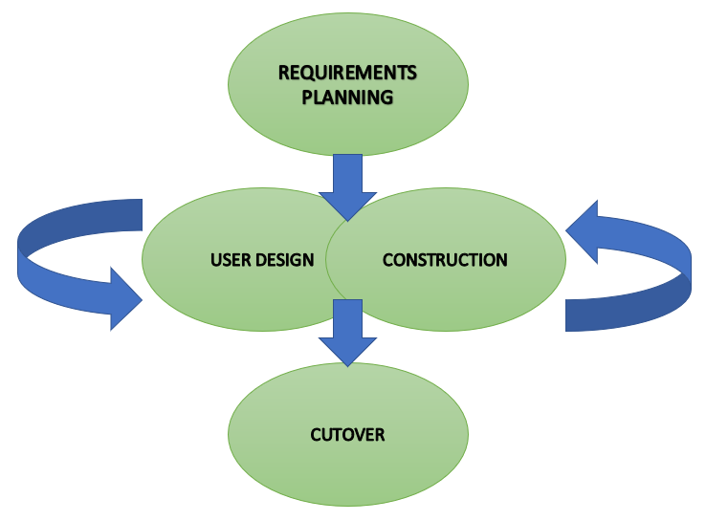Application.

Figure 2. Rapid Application Development Model (RAD)

Requirements Planning. This phase is considered the project scoping phase. The planning phase is a condensed and critical step for the success of the project.

During this stage, the proponents collaborated well to determine the requirements such as the problems and the features that can be incorporated into the system. The proponents analysed the current and potential issues that would need to be addressed during the development as well as the goals and expectations for the project.

User Design.The user design phase is the phase where clients work hand-in-hand with the developers to ensure that their needs are being met at every step in the design process.

Rapid Construction. The rapid construction phase takes all the prototypes and beta systems from the design phase and converts them into the working models. This phase is important because the developers work together to make sure everything is working smoothly in order to meet the client’s expectations.

In this phase the proponents used Adobe Photoshop to design the system, Unity 3D to build the system and used C# for the scripts.

Cutover. This is the implementation phase and where the finished product goes to launch. It includes data conversion, testing and changeover to new systems as well as user training.

The proponents conducted system consolidation to determine if the system is ready to be deployed at this point. The arrangement for the system deployment would be carried out as well as the final adjustments prior to deployment would be done if necessary.

**Data Gathering Process and Procedures**

The proponents floated online questionnaires using Google forms to the teacher in charge of teaching the topic The Universe and the Solar System to the grade-6 students of Panpacific University North Philippines Tayug Campus.

An online questionnaire is a research instrument consisting of a series of questions or other types of prompts for the purpose of gathering information from respondents via various mediums such as email, embedded over website, social media and etc. [12]. This is to determine the information needed in developing and designing the mobile application for the Grade-6 students of Panpacific University North Philippines Tayug Campus.

**Sources of Data**

The responses of the respondent are the primary sources of data. Internet research and the book that were used in teaching the topic The Universe and the Solar System are the secondary sources needed in the design and in the content of the application. In addition, the proponents also browsed various e-learning websites to distinguish the essential features that can be possibly incorporated as its additional or unique features.

**Population and Locale of the Study**

The proponents conduct this study in Panpacific University North Philippines Tayug Campus. The respondent is the teacher in charge in teaching the topic The Universe and The Solar System and the target users of the developed application are the Grade - 6 students of Panpacific University North Philippines Tayug Campus.